$e^{\left(a1+a2+…+an\right)x}$

Coefficient of xk is $\frac{{(a1+a2+…+an)}^{k}}{k!}$

* Linear Recurrence:

GF: A(x).

Recurrence: A(i) = C0Ai-1+C1Ai-2+…+Ck-1Ai-k

Let Q(x) = 1-C0x-C2x2-…-Ck-1xk-1. We can show each k -order recurrence can be described by A(x) = P(x) / Q(x) such that

* Q(x) is of degree k, and contains the coefficients of the recurrence. Additionally, the constant term is 1 (or Q(0) = 1).
* P(x) is of degree < k.

The generating functions P(x) / Q(x) and P(x)R(x) / Q(x)R(x) generate the same sequence. If we let R(x) = Q(-x) then all odd terms of the denominator will be vanished.

Another way to look at it:

Let M(x) = xk-C0xk-1-C1xk-2-…-Ck-1

Let mlxl + ml-1xl-1 + ml-2xl-2 + … + m0 be any polynomial divisible by M(x). Then:

*ml*​*Al*​+*ml*−1​*Al*−1​+*ml*−2​*Al*−2​+⋯+*m*0​=0

S(x) = *sk*−1​*xk*−1+*sk*−2​*xk*−2+⋯+*s*1​*x*+*s*0 = ​xN % M(x).

Then AN=Ak-1Sk-1+Ak-2Sk-2+…+A1S1+A0S0

A LR can be shown by the help of many different recurrences.

If A(n) = $\sum_{i=0}^{k-1}{A\left(n-b\left(i\right)\right)*c(i)}$ then,

xN % M(x) = $\sum_{i=0}^{k-1}{x^{n-b\left(i\right)}*c(i)}$% M(x)

* The generating function for the Catalan numbers is
$$\frac{1- \sqrt{1-4x}}{2x}$$

${(1+ax)}^{n}= \sum{\left({n \atop k}\right)a^{k}x^{k}}$

$\frac{1}{1-ax}=\sum{a^{i}x^{i}}$

$\frac{1}{{(1-ax)}^{n}}=\sum{\left({i+n-1 \atop n-1}\right)a^{i}x^{i}}$

${\left(\sum_{i=0}^{inf}{S_{i}x^{i}}\right)}^{2}=\sum_{i=0}^{inf}{S_{i}S_{n-i}x^{n}}$

* Fibonacci Numbers:
$$f\left[0\right]=0, f\left[1\right]=1, f\left[n\right]=f\left[n-1\right]+f\left[n-2\right]$$

$$\underset{→}{yields}G\left(x\right)=xG\left(x\right)+x^{2}G\left(x\right)+0+x$$

* Catalan numbers: 

$\underset{→}{yields}G\left(x\right)=xG\left(x\right)+1$, [+1 is beacause C[0] = 1]

* 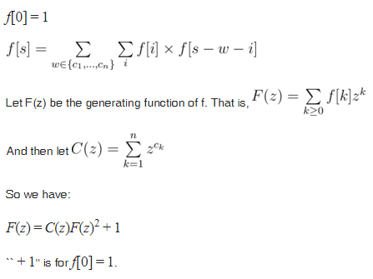
* 
* Find 

This is equivalent to the coefficient of  Thus the solution is the coefficient of xN of the above eqn, which on expanding binomially we get   thus coefficient of xN in the above eqn will be, multiplied by 

 

* 